**Today’s World**

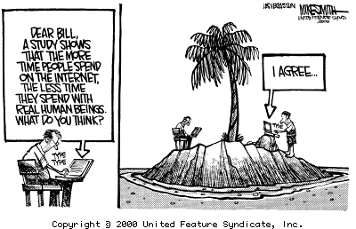

Today’s work place is so different from the workplace that existed 14 years ago when I started my first grownup job. I have never had a job that could be performed remotely before. Technology has definitely changed the makeup and cultural diversity of some companies and start-ups. In this modern-day digital age, technology has changed the way we work and communicate. Colleagues can collaborate regardless of their location, employees can work from home, and leaders can get important messages out to staff efficiently.

What I have noticed is that I need to work on not being so judgmental about working from home. As wonderful as this concept sounds and as common as it is in today’s world, it is a very new concept for me. I’m of the old school mold that regardless of what is going on in your life you show up to work. You just make it happen. You don’t get paid to nap, grocery shop, or what while your toilet gets installed, you are paid to be at your desk.

In today’s business world of video meetings and teleconferences, the value of face-to-face encounters can often get overlooked. That is unless you believe, like I do, that face-to-face interaction is and will continue to be our most effective form of communication. Despite the clear advantages of digital communication and telecommuting, there are many restrictions that still exist, and it would be a mistake to assume that face-to-face communication in the workplace could lose its worth. Like many other soft skills, communication can be undervalued in organizations because it’s difficult to measure, but its power in shaping business outcomes, company culture and staff engagement should not be underestimated.

**Michael Massari could not have said it better.** “No matter what industry you work in, we are all in the people business. Regardless of how tech-savvy you may be, face-to-face meetings are still the most effective way to capture the attention of participants, engage them in the conversation, and drive productive collaboration. If we don’t continue to nurture strong and positive personal relationships with our clients and coworkers, we won’t build trust, understanding, or a sense of a shared mission – all of which are critical elements to successful partnerships and business success.”

**A shared feeling is that** visual technology (Skype, FaceTime, HipChat, GTM etc.) is like an enhanced phone call. The ability to see each other is a great improvement – but it can’t replace face-to-face. While more of our business and personal communications are moving online, psychologist [Susan Pinker](http://www.susanpinker.com/), argues that our growing lack of social contact is hindering our ability to build strong business relationships, and may also have a negative impact on our health and happiness. “In a short evolutionary time, we have changed from group-living primates skilled at reading each other’s every gesture and intention, to a solitary species; each one of us preoccupied with our own screen,” she writes.

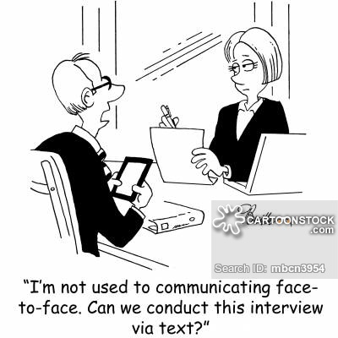

Pinker argues the movement toward communicating through technology stands in the way of our most basic biological necessities. Face-to-face interaction causes the release of the hormone oxytocin. Oxytocin is not just a necessary hormone for mother & child bonding, but, when people connect physically–through a handshake, a pat on the back or a high five–oxytocin is released, promoting feelings of attachment and trust, facilitating greater collaboration among team members. Oxytocin plays a number of other important roles, such as boosting mood and improving our ability to learn and remember. Increased social contact has also been shown to dampen cortisol–the chemical that is released when we’re under stress. These chemical reactions do not occur through email or even a Skype chat, but through real-life human-to-human contact.

I see it on college campuses too often, students come out of class and immediately pull out their phone to communicate with a “digital friend” when if they just stopped for a second, they would realize they have hundreds of potential friends’ inches from them in all directions. We are definitely at a tipping point. Incorporating more face time in the workplace requires a rethink of communications. Here is the dilemma. In business, digital connection with social media is considered to be the Holy Grail. It’s cheaper; it’s more convenient. But when it comes to worker productivity, happiness, and satisfaction, the companies that are focusing on face-to-face interactions are leading in their industry.

**Advantages of Face-to-face communication.**

**Non-verbal cues**

Non-verbal cues are just as crucial when communicating as the words we say. Everything from body language and facial expressions to attentiveness and engagement can indicate different thoughts and feelings – each of which can only truly be observed through face-to-face communication.

**Efficiency**

Face-to-face communication and in-person meetings can boost efficiency. Instead of spending an entire day emailing back & forth, you can hash out all the details of a project in one go. A face-to-face meeting can also boost creativity as the overall energy in the room will be higher, resulting in people feeding off each other, brainstorming and a gathering of collective ideas. Face-to-face meetings can also be more effective for those who may struggle with written communication. People tend to be more fluid with verbal communication.

### **Stronger working relationships** There is no doubt that if you’re not physically in the workplace, or you choose email to communicate or over phone rather than face-to-face interactions, you’re not going to be as connected with your colleagues. A sense of community comes with the ability to interact and socialize, and this sets the foundation for trust, and ultimately better working relationships.

### **Engagement and innovation** Face-to-face communication also helps to build collaborative environments that inspire and energize employees to participate in meetings, brainstorming sessions and more. These environments foster engagement and innovation, which is important for employee satisfaction as well as company culture and growth.

### **Addressing sensitive issues** When addressing sensitive issues, put down the phone, move away from the keyboard, and make the effort to engage in-person – it will be crucial to a successful outcome. Whether you are providing specific feedback to a staff member or addressing an issue with a colleague, much can be misinterpreted or lost when communicating via technology.

### **Clear and concise communication** How many times has an email been misunderstood, misread or perceived by another party to be rude when that wasn’t the intention? Face-to-face conversations minimize the risk of miscommunication, promoting more effective business practices. The importance of real conversations, in real time and real rooms, should never be underestimated.

